Notes on the (mis)use of ‘value’ in Integrated Care Systems (ICSs) to enable ‘unimpeachable’ financial cuts to state provided healthcare.

Value only arises out of exchange processes but……’the producers do this without being aware of it.
Value, therefore, does not have its description branded on its forehead; it rather transforms every product of labor into a social hieroglyphic. Later on, men try to decipher the hieroglyphic, to get behind the secret of their own social product: for the characteristic which objects of utility have of being values is as much men’s social product as is their language. (166–7)” ‘

Introduction

In order to move forward on the ambition to limit healthcare spending, our new ICSs will be given a fixed annual budget with a smaller variable element of funding tied to ‘system alignment’(the development of new models of care and the reduction of ‘unwarranted variation’) to further support the development of ‘sustainable’ services’. In order to cope with having less money available to maintain levels of service over time, systems must push efficiency to its maximum, but even with this it is inevitable that choices about where to spend a limited budget will have to be made. To help with this, the government wishes to commission for ‘value’ which they define as:
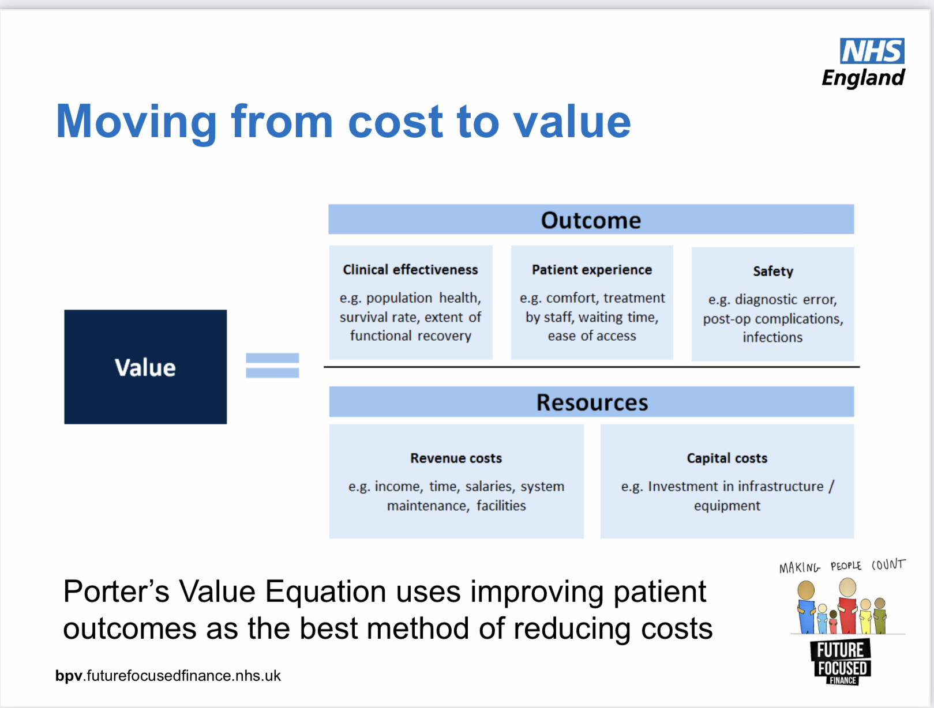

However, this equation which to be applied to services, is not a true measure of ‘value’, it is simply a variant of ‘cost effectiveness/benefit’ measures. To say whether any new intervention/service represents good ‘value’ depends upon moving beyond the individual service, to examine its performance in relation to other interventions competing for funding in the same and, perhaps more controversially, other areas of healthcare, while also including the complex, socio-politically defined criteria of precedence. The latter are decidedly missing in the above equation and indeed may be denied, at least in public, but they have been realised to exist for decades within the NHS especially among those working in and using mental health, disability and older people’s services- the so-called ‘Cinderella services’. It also seems that when budgets are ‘stretched’, as happened when the government chose to adopt austerity measures following the most recent 2008 financial crash, it is the older and more vulnerable who are to die.

Issues about ‘value’ in healthcare including ‘best value’ for the system

The ‘value healthcare’ paradigm

The ‘value healthcare’ paradigm as developed in this country by Professor Muir Gray is based on the International Healthcare Improvement (IHI) Triple aim and describes three different elements to ‘value’:

- personal value –to ensure that each individual patient’s values are used as a basis for decision making in a way that will optimise the values for them. It incorporates the IHI ‘enhancing patient experience’ but in addition to this, ensures that a patient’s values are taken into account with regard to the outcomes that are delivered to them through ‘preference- based informed decisions’ as in the ‘shared decision making’ element of NHS Personalised Care.
- technical value – to ensure that resources are used optimally; this concept is referred to as technical efficiency or simply efficiency by economists and relates to the interventions available for a given condition
- allocative value –to ensure that resources are allocated optimally and equitably; this concept is referred to as allocative efficiency by economists and relates to population health where decisions are based not only on best current evidence but also on ‘the unique health problems of the population or patient group and on the ‘values’ of that population or patient group’

As far as personal value is concerned, while informed consent is absolutely critical in medicine, so is disinterested expert advice within a trusted relationship with a professional who knows your ‘case’. ‘Sharing of decision making’ featured in the McKinsey 2009 Report where it was instead identified quite differently as ‘a mechanism to reduce rates of discretionary surgery’ (p.55). A patient’s decision whether to proceed with, for example, a surgical procedure can be heavily influenced by the balance of potential risks and benefits as presented to them by an expert. Within a system that demands budgetary responsibility from all staff and monitors performance, clinicians may be put into an invidious position- especially if the service they work in is approaching or has reached over-spend. The concept of ‘allocative value’ (see below), perhaps along with externally set limits on the numbers of certain procedures, will help staff to deal with any discomfiture that denial of care may bring.

The concept of ‘overuse’ in ‘allocative value’

The NHS RightCare programme introduced the idea of ‘unwarranted’ variation of care which was highlighted by marked geographical variations in the levels of care given as shown in Atlases of Variation. Alongside the usual causes of ‘underuse’ of care such as inefficient procurement and performance, poor access to services or lack of referral, a concept of ‘overuse’ of care was also developed. Both were seen as potential causes of ‘low value’ care. With ‘overuse’ it is claimed that even a service that is of very high quality, that is delivered safely and at low cost, may be of ‘lower value’ than making use of those same resources for another group of patients if the service has gone beyond what is called the ‘point of optimality’ as first defined by Avedis Donabedian and described in his classic diagram shown below. It is claimed that with the spending of a finite resource, only once the whole population (ICS or system) is considered can issues of ‘value’ become clear; and it is ‘allocative value’ that needs to be optimised. In other words ‘best value for the system’ can be achieved only when it is not possible to switch resources from one budget to another and achieve more ‘value’.
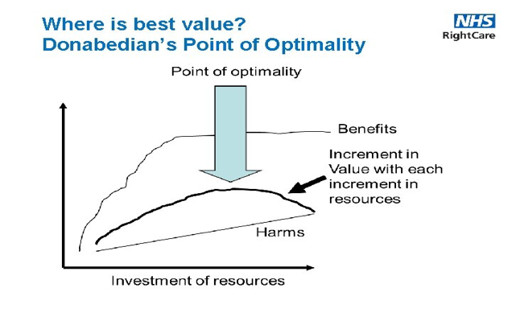
So the argument is that where there is a demand not to increase, or even to reduce the money spent in a system, services can be rationed or cut with equanimity when the reduced amount of money can be spent somewhere or some how else that provides more ‘value’, and so increases the total ‘value’ achieved within the system. To do this requires complex comparisons and judgements and it is no surprise that, driven in particular by the difficult clinical allocation decisions required in the management of COVID-19, algorithms are already being developed to allocate limited resources in what is described as a ‘fair, economically efficient, strategy-proof, and computationally tractable way’. Such an algorithm could prove useful in the future to protect healthcare workers from ‘moral injury’, which can occur when they are ‘forced to make decisions that contradict their professional and moral commitments—the challenge of knowing what care patients need but being unable to provide it due to constraints beyond their control’.

The ‘overuse’ aspect of ‘unwarranted’ variation described and the ‘value based’ rationale for moving monies around within a system are problematic and merit consideration.

Firstly, ‘harms’ as shown by Donabedian are not specific to an intervention: technological improvements may reduce them and intrinsic patient factors may alter them e.g. increased age, co-morbidities or long-standing disabilities may be associated with greater risk of harm. If a wanted intervention that brings benefit and improves prognosis or quality of life is achieved for the ‘at greater risk of harm’ older person or the person with disabilities, and if the ‘person who does not need the intervention’ receives it (as has been claimed¹²) but with minimal risk of harm, where does ‘value’ lie? Clearly the former intervention is of ‘value’, especially if it is long lasting and does not require repeating, while the latter should always be ethically and financially what is called a ‘never’ event even with zero harm! Also, it is not clear whether or not the model also means that if a particular service deals in treatments specifically for particular patient groups with a higher risk of ‘harm’, then the service will reach the ‘optimality’ threshold for stopping funding sooner i.e. after fewer numbers have been treated?

Secondly, ‘harms’ related to delayed or denied treatments must also be considered and balanced against the harm of intervention. Lack of resource generally, or spend somewhere else where it may be felt to be of ‘better value’, will mean that people are denied or have to wait longer for NHS treatment and may not be able to pay for it (it seems perhaps, and it is the author’s experience, that interventions may become more beneficial if you can pay). Certainly in joint replacement surgery, delay may lead to physical and psychological decline, and the extensive use of anti- inflammatory medication can cause significant harm, with increased risks of poorer surgical outcomes, side effects, diminished quality of life and associated ‘costs’ for patients.

Thirdly, if an NHS service serving an ICS population is claimed to be at the point of ‘optimality’ and no further resource will improve the benefit it creates within the system, then surely it must be assumed that there is no need or reason for any of the system population to seek alternative provision of a similar service elsewhere, unless of course NHS consultants working privately use a different set of clinical and possibly ethical criteria.

‘Allocative value’ is therefore potentially a way to reduce and delay high cost secondary care elective interventions in order to generate income to the system from those who are able to, and choose to pay. It is generally stated the money saved by each system from dealing with any ‘unwarranted’ variations such as ‘overuse’, can then be used to help to address the social and healthcare inequalities it has identified-the cause of so much morbidity. The Long Term Plan is for people with non-communicable diseases to self-care, improve their ‘lifestyles’, and, if wanted and able, they can use and boost the so apparent developing markets and pay for consultations, physiotherapy, treatment apps, varied advertised alternative treatments, and psychological support. Along with cost-efficiencies, it is this hoped for redistribution of limited resources towards preventive interventions that is expected to reduce population morbidity and future levels of state funding.

Optimising ‘allocative value’ in systems (‘best value’)

In order to help commissioners optimise allocative value i.e. when it is not possible to switch resources from one budget to another and achieve more value, the ‘socio-technical allocation of resources (STAR) tool’ was developed by the London School of Economics. This aims to allow clinicians and patients to reflect on the balance of resources and ‘optimise’ resource allocation for that population’s needs. As an example, when looking at a condition such as chronic obstructive pulmonary disease (COPD), there will be a wide range of different interventions provided by different budgets. Using STAR a decision may be made to switch some of the limited resources from triple drug therapy (used to treat people with severe, resistant disease) to smoking cessation and pulmonary rehabilitation. This, as with all allocative decisions in a system’s budget, has important ethical implications as any rationing of care to improve ‘system value’ can have profound consequences for individuals.

‘Accountability for reasonableness’

The ethics that have been developed in relation to the implications of these allocative decisions have been influenced by the concept of ‘accountability for reasonableness’, as defined by Harvard-based ‘ethics and resource’ Professors Norman Daniels and James Sabin:

‘Accountability for reasonableness is the idea that the reasons or rationales for important limit-setting decisions should be publicly available. In addition, these reasons must be ones that ‘fair-minded’ people can agree are relevant to pursuing appropriate patient care under necessary resource constraints’

This is their central thesis, and it needs some explanation. By ‘fair-minded’, they do not simply mean their friends or people who just happen to agree with them. They mean people (this will be members of the public in the system population where resources are to be cut) who in principle seek to cooperate with others on terms they can justify to each other. Indeed, fair-minded people accept the ‘rules of the game’– or sometimes seek rule changes – that promote ‘the game’s essential skills and the excitement their use produces’.

The decision to ‘reasonably’ deny or ration healthcare for some patients may be made with the support of members of the public who are told that resources for healthcare have to be limited for economic reasons, and who may have no notion of:
- any global ‘bigger economic picture’,
- corporate demands for increased national economic competitiveness,
- the underfunding in the NHS
- underfunding in relation to our OECD peers,
- the decisions to use cost inefficient internal markets
- the cost inefficient private provision and investments,
- the profit generation by healthcare corporations,
- global consultancies and global pharmaceutical companies, and of the wish to grow ever more capital by creating new markets and in so doing increase the unequal distribution of wealth
- the fact that wealth inequalities generate health inequalities.

Are these the ‘rules of the game’ and the reasonableness that people need to be ‘fair-minded’ about? The use of language and ideas to gain support for what are presented as ‘popular’, necessary changes whilst hiding the major reasons for such change is well described by Stuart Hall. The less wealthy and more needy in our society will have to go without elements of state funded health and social care services and agree to alter their behaviours and lifestyles; apparently this is in the ‘national interest’- to keep us all from financial ruin.

The use of analytics to try to generate ‘value’ (cut costs)

The use of large data sets and analytics in ICSs currently depends on paying huge amounts of money to accredited private multinational corporations as listed on the HSSF. The maintenance of IT systems and the storage, curating and analysis of data sets means that these commercial relationships and funding streams will continue.

Whilst analytics involves the development and use of ‘algorithms’, Artificial Intelligence (AI) is generally seen as ‘software used by computers to mimic aspects of human intelligence’ especially when they learn from data how to do tasks. The UK government has set out a legal definition of AI in the National Security and Investment Act 2021, and produced a National AI Strategy with the intention ‘to make Britain a global AI super-power’.

Artificial Intelligence is a general purpose set of technologies with many possible applications that are expected to have a transformational impact on the whole economy, and indeed all of society. While healthcare in general could benefit enormously from AI’s ability to identify and predict disease and accelerate the development of medicines, within the ICS the major use of AI will be to forecast vital metrics around hospital admissions, bed capacities and workforce issues, and also to predict those patients at risk of high cost service use. As mentioned above, AI may also be used to help with the difficult decisions about how to allocate restricted resources to create ‘best value’ for a system.

The themes in AI policy are mainly similar to those of tech and digital policy more widely: the way private interests can act to secure profits-also seen as commercialisation journeys; the reliance on internationally mobile talent; the importance of large amounts of data; and the consolidation of economic functions onto platforms. However there are some key examples of difference with AI that require extra consideration:

- in regulatory matters, an AI system’s autonomy raises unique questions around liability and fairness (an important question is whether an AI company can be held liable for malfunctioning AI) as well as risk and safety in a way which is distinct to AI, and these issues increase with the relative complexity of any algorithm;
- ii) there are serious questions of transparency and bias about decisions made by AI systems
- iii) there are greater infrastructure requirements for AI services in terms of access to expensive high performance computing and large data sets ;
- iv) multiple skills are required to develop, validate and deploy AI systems, with concerns about the length and cost of any product journey.

When analytics are inserted into funding mechanisms or incentives mandated through policy (see paper on Payment systems), and into regulatory requirements used to evaluate products or services for safety and efficacy, they take precedence over other ‘ways of knowing’. Data and analytics have been granted considerable perceived authority to solve problems in healthcare and biomedicine but at the same time, there is a potential for a tremendous impact on social and political life. There are implications for the surveillance of citizens with social sorting- the use of information to create profiles that may have consequences for the way individuals, including users of social services, are viewed and dealt with. There could also be challenges to the professional autonomy of health and social care workers if data is constantly collected and ‘scooped’ from both ‘medical/social’ and ‘consumer’ domains and used to sketch portraits to characterise them and their performance.

It is also important to ask who is not served by the tremendous flow of funds and information. While enormous organisational efforts are preoccupied with interoperability of data sets, individuals are much more likely to worry more about the continuing difficulty in acquiring information that is most relevant to their own well-being, and how to prevent it from flowing in a way that may indeed cause them harms.

Karl Marx, Capital: A Critique of Political Economy, Volume I, trans. Ben Fowkes (London: Penguin Classics, 1990) p 166-7
See Paper on Payment systems and schemes
https://bmjopen.bmj.com/content/7/11/e017722
https://journals.sagepub.com/doi/full/10.1177/0141076816679781
In 2006 he developed the NHS's framework for value (triple value). He was then the founding Director of the NHS Rightcare programme, trying to change the culture of the NHS to become a higher value organisation. He published many influential Atlases of Variation. He then left to found Better Value Healthcare, and then the Oxford Centre for Triple Value Healthcare, a mission driven social enterprise.
http://www.ihi.org/Engage/Initiatives/TripleAim/Pages/default.aspx 1.Improving the patient experience of care (including quality and satisfaction); 2.Improving the health of populations; and 3. Reducing the per capita cost of health care.
https://www.england.nhs.uk/personalisedcare/
https://www.healthemergency.org.uk/pdf/McKinsey%20report%20on%20efficiency%20in%20NHS.pdf
https://www.england.nhs.uk/rightcare/
https://www.england.nhs.uk/south/wp-content/uploads/sites/6/2017/03/realising-the-benefits-right-care.pdf
Seven Pillars of Quality Arch Pathol Lab Med 1990 Nov; 114 (11):1115-8. Seven attributes of health care define its quality: (1) efficacy: the ability of care, at its best, to improve health; (2) effectiveness: the degree to which attainable health improvements are realised; (3) efficiency: the ability to obtain the greatest health improvement at the lowest cost; (4) optimality: the most advantageous balancing of costs and benefits; (5) acceptability: conformity to patient preferences regarding accessibility, the patient-practitioner relation, the amenities, the effects of care, and the cost of care; (6) legitimacy: conformity to social preferences concerning all of the above; and (7) equity: fairness in the distribution of care and its effects on health. Consequently, health care professionals must take into account patient preferences as well as social preferences in assessing and assuring quality. When the two sets of preference disagree the physician faces the challenge of reconciling them.
https://www.hfma.org.uk/docs/default-source/our-networks/healthcare-costing-for-value-institute/value/0416-7---canada-ma-v3-arj
https://static1.squarespace.com/static/5e959a5c9826e26b27f314fe/t/6078c60a3139356d6cb9aae3/1618527759791/eff-reserves-report.pdf
https://www.thelancet.com/journals/lancet/article/PIIS0140-6736(21)00436-0/fulltext
https://www.health.org.uk/publications/long-reads/waiting-for-care
https://www.longtermplan.nhs.uk/wp-content/uploads/2019/08/nhs-long-term-plan-version-1.2.pdf
http://wwww.lse.ac.uk/Research/Assets/impact-pdf/nhs-deliver-better-care-less-money.pdf
https://www.hfma.org.uk/docs/default-source/our-networks/healthcare-costing-for-value-institute/value/0416-7---canada-ma-v3-arj
Daniels N, Sabin J. The ethics of accountability in managed care reform. Health Affairs. 1998;17:50–64. Available at https://www.alnap.org/system/files/content/resource/files/main/%5Bdaniels---sabin-1998%5D-ethics-of-accountability-in-managed-care-reform.pdf
Daniels, N. and Sabin, J.E. (2008) Setting Limits Fairly, Learning to Share Resources for Health. Oxford University Press. (p.44). quoted in https://www.hfma.org.uk/docs/default-source/our-networks/healthcare-costing-for-value-institute/value/0416-7---canada-ma-v3-arj
https://www.tni.org/files/article-downloads/23_msismvisualpresentations-_what_is_msism.pdf
http://www3.weforum.org/docs/WEF_HE_SustainabilityHealthSystems_Report_2012.pdf
https://fullfact.org/health/spending-english-nhs/
https://www.kingsfund.org.uk/blog/2016/01/how-does-nhs-spending-compare-health-spending-internationally
https://chpi.org.uk/papers/analyses/at-what-cost-paying-the-price-for-the-market-in-the-english-nhs/
https://chpi.org.uk/wp-content/uploads/2018/10/CHPI-PFI-Options-Sep18-FINAL.pdf
https://democracy.camden.gov.uk/documents/b27994/Supplementary%20Agenda%20-%20Deputations%2007th-Apr-2021%2018.30%20Health%20and%20Adult%20Social%20Care%20Scrutiny%20Commi.pdf?T=9 see deputation by Dr Brant Mittler JD MD
https://thenextrecession.wordpress.com/2021/05/02/wealth-inequality/ Michael Roberts is an economist who works in the City of London
https://www.theguardian.com/inequality/2018/sep/18/kate-pickett-richard-wilkinson-mental-wellbeing-inequality-the-spirit-level Richard Wilkinson, Kate Pickett, The Spirit Level: Why More Equal Societies Almost Always Do Better. Allen Lane 2009.
Hall S.’The Great Moving Right Show’,Marxism Today, January,1979 access at http://banmarchive.org.uk/collections/mt/pdf/79_01_hall.pdf
£800 million ‘Digital Capability for Health’ framework; £700 million ‘Health Systems Support Framework’£5 billion from Treasury for “health R&D”, £2.1 billion invested in IT, technology and digitalising the NHS
https://www.england.nhs.uk/hssf/supplier-lists/
a set of mathematical instructions or rules that, especially if given to a computer, will help to calculate an answer to a problem https://dictionary.cambridge.org/dictionary/english/algorithm
https://www.newscientist.com/definition/artificial-intelligence-ai/#ixzz7IL9sfh8E
https://www.gov.uk/government/news/new-and-improved-national-security-and-investment-act-set-to-be-up-and-running
https://assets.publishing.service.gov.uk/government/uploads/system/uploads/attachment_data/file/935774/nsi-consultation.pdf Page 32
https://www.gov.uk/government/publications/national-ai-strategy/national-ai-strategy-html-version
https://blogs.lse.ac.uk/businessreview/2021/08/16/artificial-intelligence-liability-the-rules-are-changing/
As AI systems become more powerful and more general they may become superior to human performance in many domains. If this occurs, it could be a transition as transformative economically, socially, and politically as the Industrial Revolution. This could lead to extremely positive developments, but could also potentially pose catastrophic risks from accidents (safety) or misuse (security). On safety: our current systems often go wrong in unpredictable ways. There are a number of difficult technical problems related to the design of accident-free artificial intelligence. Aligning current systems’ behaviour with our goals has proved difficult, and has resulted in unpredictable negative outcomes. Accidents caused by more powerful systems would be far more destructive. On security: advanced AI systems could be key economic and military assets. Were these systems in the hands of bad actors, they might use it in harmful ways. If multiple groups competed to develop it first, it might have the destabilising dynamics of an arms race. Mitigating risk and achieving the global benefits of AI will present unique governance challenges, and will require global cooperation and representation. https://www.cser.ac.uk/research/risks-from-artificial-intelligence/
In the field of medical triage, one of the most cited studies on algorithmic bias was published by Obermeyer et al. (2019). A large national health care system, unnamed in their paper but identified subsequently as UnitedHealth Care, was using algorithms to identify patients that could benefit the most from expensive care management programs. These programs were conceived as a way to provide additional resources (for example, dedicated nurses or additional appointments) to the sicker population of their patients. Obermeyer and his colleagues showed that at the same level of sickness, white patients were referred more frequently to these programs than black patients. In other words, the algorithm showed a racial bias against black patients who had to be sicker than whites to take advantage of these additional resources. See: AAAS (2021). Artificial Intelligence and COVID-19: Applications and Impact Assessment. (Report prepared by Ilana Harrus and Jessica Wyndham under the auspices of the AAAS Scientific Responsibility, Human Rights and Law Program).
http://ndl.ethernet.edu.et/bitstream/123456789/76543/1/146.pdf.pdf#page396 Linda F. Hogle The Ethics and Politics of Infrastructures: Creating the Conditions of Possibility for Big Data in Medicine
https://medium.com/iipp-blog/worker-organisation-and-the-challenge-of-shaping-markets-in-the-age-of-surveillance-capitalism-cc9dc4da37c5
https://bigbrotherwatch.org.uk/campaigns/welfare-data-watch/#introduction
https://www.digitalhealth.net/2020/11/nhs-digital-signs-a-deal-to-help-improve-data-sharing-across-organisations/

